2021 - 2022

UNIVERSITY
HEALTH
SERVICE

Richard Verney Health Centre
6 Bristo Square
Edinburgh
EH8 9AL

Telephone: 0131 650 2777
Fax: 0131 662 1813
www.health-service.ed.ac.uk
Email: Clinical.s70592@nhslothian.scot.nhs.uk
Info which may be useful re general health information is available on an App, which is produced by Expert Self Care Ltd and is free to download from your App Store. Look for ESC Student.

INDEX

Staff List 3
Map of Practice Area
And Location of Practice 4

About the Practice 5,6,7

Services provided by the
University Health Service 8,9

Other Services within the
Health Centre
Rights and Responsibilities 10

Confidentiality
Access to Health Records 11

Suggestions
Complaints
Local Health Board Details 12

STAFF

Doctors:
Dr Bill Donovan MBBCh BAO DObs DCH MCOphth MRCGP
Registered Ireland 1986
Dr Judith Richardson MBChB DRCOG DCH DFSRH FRCGP M Med Ed
Registered Edinburgh 1991
Dr Susan Arnold, MBChB, DRCOG, DFSRH, MRCGP
Registered Aberdeen 2004
Dr Ewan Clark MBChB BMSc DRCOG DFSRH DCH, DIPTRAVMED,MFTM RCPS (Glasgow) MRCSEd MRCGP
Registered Dundee 2004
Dr Nina Talbot, MBChb, DRCOG, DFSRH, DCH, MRCGP
Registered Edinburgh 2006
Dr Michael Diamond, BSc, PhD, MBCHB, MRCGP,DRCOG, Dip BSLM/IBLM
Registered Aberdeen 2010
Dr Carolyn Elliott, MBChB, MRCGP, DFSRH, DRCOG
Registered Dundee 2005
Dr Louise Duthie, MBChB, DRCOG, DFSRH, MRCGP
Registered Aberdeen 2005
Dr Diane McCutcheon MBChB, DRCOG, DFSRH,MRCGP (Term Time only)
Registered Edinburgh 2000
Dr Isabelle Crawford BSc, MBChB, MRCGP, DCCH (Term Time only)
Registered Manchester 1991
Dr Sally McNeill MBChB, DRCOG, MRCGP (2006)
Registered Edinburgh 2001
Dr Yilang Li – BSc, MBCHB, MRCGP
Registered Edinburgh 2011
Dr Kathryn Marshall BSc, MBCHB, MRCGP, DFSRH
Registered Edinburgh 2011
Dr Samuel Walker MBBS, MRCGP
Registered York 2009
Dr Ross Dinwoodie
Registered
Dr Deborah Bassett
Registered

Practice Nurses:
Kris Head Practice Nurse BN Adult Nursing

Clinical Support Worker:
Louise Foley SVQ3

Allied Healthcare Staff:
Alison Rowe BPharm PGDip Independent Prescriber
Eilidh Milliken GP Practice Pharmacist
Carol Li Pharmacy Technician
Kerrie Crisp BSc (Hons) Physiotherapy

Practice Business & Development Manager:
Jean Grant, MA(Hons), Dip IA, Dip HSM

IT Manager: Medical Typists:
Anne-Marie Fraser (HND) Laura Mackey
Lynne McMillan
Wilma Ferguson

Reception Manager: Records/System Administrator:
Lorraine Jameson Sharon Murphy

Receptionists:
Ellen Moffat Laura Mackey
Wilma Ferguson Lynne McMillan
Ray Hedley Caroline McGlade
Mavis Millar Sara Carmichael

University Health Service
Richard Verney Health Centre, 6 Bristo Square, Edinburgh EH8 9AL

Tel: 0131 650 2777 Fax: 0131 662 1813
Email: Clinical.s70592@nhslothian.scot.nhs.uk

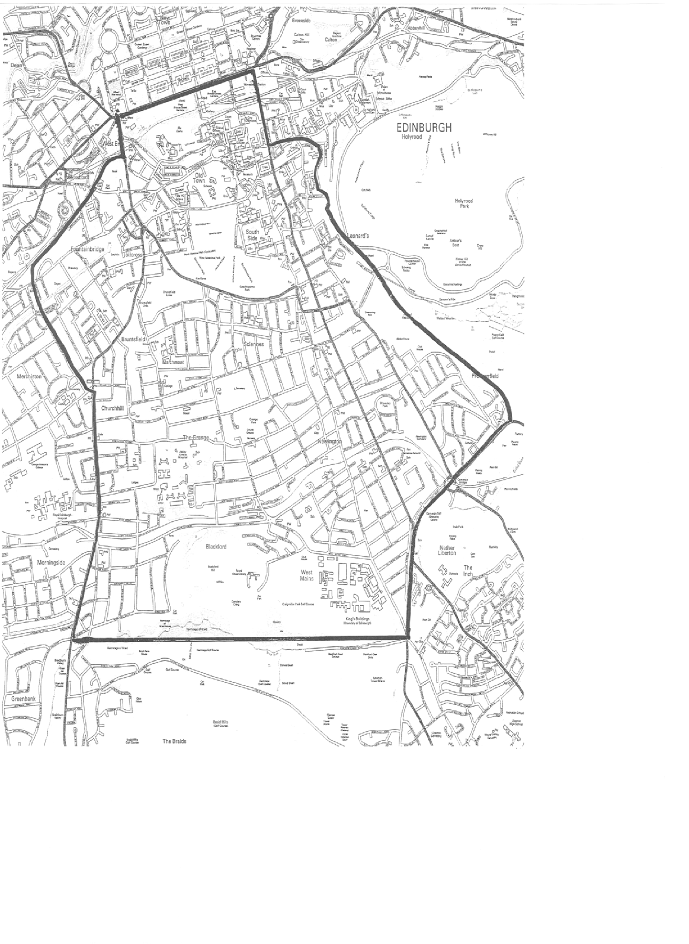.
The entrance to Richard Verney Health Centre is on the opposite side of
Bristo Square to the McEwan Hall – Our reception is on the 3rd floor.
See photo on our website.

ABOUT THE PRACTICE

The University Health Service is an independent National Health Service
partnership of general practitioners, who rent premises from the University, and
offer full GP services to patients who live within the practice area (see map page
4), and who choose to register with the practice.

TRAINING AND EDUCATION:
The practice has been recognised as the training practice for fully qualified doctors and medical students who have chosen general practice as their career. These doctors work with us and are available for consultation. Video equipment may occasionally be used with the patients consent and consultations with medical students will be checked by a fully qualified doctor as part of their training.

FACILITIES FOR THOSE WITH IMPAIRED MOBILITY/HEARING:
The Health and Wellbeing Centre has disabled access via the main entrance there and up the ramp, through the automatic doors into the foyer at pharmacy with lift access through another automatic door and come to 3rd floor reception. Sign posting is in situ.

HOW TO REGISTER WITH THE PRACTICE:
Please visit our website and follow the link titled “How to Register With Us”. Here you will find a link to Campus Doctors and all our registration forms which you can complete electronically and send securely to the Practice. Once your registration documents have been submitted, you will receive an email confirming this and providing you with further information about contacting us, making an appointment, and how we are currently dealing with Covid-19 safety measures such as social distancing and access to the Practice.

HOW TO SEE A DOCTOR:
At present, we are operating a different consultation format due to guidance provided to us so allowing us to adhere to Covid-19 regulations relating to social distancing.
Only those who have been advised by one of our Doctors to come into the Practice for an appointment should do so.

Our consulting hours are Monday – Friday 9am – 5pm.

On our New Patient Section of the website is a copy of our Signposting poster highlighting where you can seek help for specific health issues. It is not always necessary to be seen by a doctor.

If you do however feel you have a requirement to be seen by a doctor then you should telephone the Practice during opening hours on 0131 650 2777. The receptionist will note your details and the reason for your call and either allocate you an appointment or one of our doctors will call you back to discuss your problem and how that will be dealt with. Please do not come in to the Practice unless you have been told specifically to come in. If we ask you to come in then you must come directly to our third floor reception and adhere to the following:

- Wear a mask (valved masks are not permitted)
- Wash your hands before arrival
- Come to the appointment alone
- Come to the third floor reception but only at the time of your appointment.

The first time you attend the Practice for an in-person consultation please bring proof of ID with you to allow us to check your registration.

EMAIL CONTACT
For confidentiality reasons please note that NO medical correspondence or requests for appointments or prescriptions can be dealt with through the Practice email address.

PRACTICE NURSES

Our Practice Nurses are also operate an appointment system.
Therefore please call the Practice on 0131 650 2777 and the receptionist will allocate you an appointment slot.

INTERPRETERS
If you feel that you will require a foreign language or sign language interpreter
to allow you to understand your consultation then please telephone reception at least 5 days in advance of your appointment to discuss this.

PRACTICE OPENING TIMES: 8.00 am – 6.00 pm, Monday to Friday

APPOINTMENTS TERM TIME and VACATION

Monday - Friday 09.00 – 17.00
Routine consultations by appointment throughout the day.
Routine appointments are usually 10mins.

PUBLIC HOLIDAYS: Closed (Dates for these are posted on our website)

HOME VISITS:
If at all possible we prefer to see patients at the surgery where full investigative
and treatment facilities are available, rather than at home. Should a home visit
be necessary we will be pleased to do this.

It is very helpful if requests for such visits can be phoned in before 10 a.m.
(tel: 0131-650-2777).

Please do not feel offended if the receptionists ask for some simple details
of your illness - it does help the doctor to arrange to see you rapidly if your
symptoms sound serious. The Duty Doctor may also telephone and speak to you.

EMERGENCY CALLS:
Between 08.00 and 18.00 hours, the Practice Duty Doctor can always be
contacted by telephoning: 0131-650-2777

Out of hours, (that is between 18.00 and 08.00 hrs, Monday – Friday, at weekends, and on public holidays) NHS Lothian is responsible for medical care.

To contact this service, please phone: NHS 24 on tel. No 111

NHS24 is also available for advice 24 hours a day, 7 days a week.
Tel. No. 111 website: www.nhs24.com

REPEAT PRESCRIPTIONS:
If your University Health Service doctor authorises repeat prescriptions for
you, you will be given a ‘Repeat Prescription Ordering Form’, detailing your
medicines and the number of occasions these may be re-prescribed before you
have to see the doctor to review your medication.

When you require ‘repeats’, please send it in to us (with a stamped addressed envelope) or if you require to come into the Practice you can post this in our prescription box on the 3rd floor landing and the prescription will be available for
collection in 2 working days, at your preferred pharmacy.. If you are registered for on line booking you can request “repeats” on line.

Please note that you have to consult a doctor at the University Health Service
before you can use the repeat prescription facility.

TEST RESULTS:
Please telephone for test results from 11am to 4pm, Monday to Friday

CHANGE OF ADDRESS:
It is essential that any change of address be notified to the practice as
soon as possible. Failure to do so may result in NHS Lothian withdrawing
your registration.

Please let us know your email address & mobile telephone number and
remember to tell us if you change these.
If you move out with our practice area, you should register with a local general
practitioner. When in doubt about your address, please ask at reception.

Please email us on clinical.70592@nhslothian.scot.nhs.uk (link via our website), phone us or call into the practice. Please state name, date of birth, old and new address details.’

NON-NHS WORK:
Requests for completion of medical forms (e.g. Camp America), full medical
examinations (e.g. pre-employment, insurance) or shorter medicals should
be discussed with the receptionist in the first instance and not taken
directly into a GP appointment. This will be assessed on whether or not an
appointment is necessary and as this work is not covered by the National
Health Service general medical services, a fee will normally be charged. You
should phone the surgery 48 hours after handing in your request for this
information. A charge will be made for private prescriptions issued by the
Doctors for travel.

SERVICES PROVIDED BY THE UNIVERSITY HEALTH SERVICE

CONTRACEPTION:
Contraceptive advice is always available from the doctors and nurses. We
are committed to providing a confidential and easily accessible contraceptive
service for our patients.

Contraceptive implants and intrauterine devices (IUD’s, IUS) are fitted and
removed by doctors at the practice in a dedicated, long acting and reversible
contraceptive (LARC) clinic. You will need to make an appointment at the clinic
or with any doctor/nurse for an initial discussion prior to insertion.

For routine, or emergency contraception, please see a doctor during
appointment or open access surgeries.

The nursing team can see patients for repeat contraceptive pill supplies of
certain brands, also for emergency contraception. A list of those included is
available at reception or on our website.

CERVICAL SMEAR TESTS:

A Scotland wide recall system is in place routinely for women aged 25-64 years to allow them to have a routine smear every 5 years and up to age 70 for non routine patients. If you receive a letter offering you a smear then please call the practice to make an appointment with a nurse on 0131 650 2777.

CHILD HEALTH SURVEILLANCE CLINICS:
This clinic is run by a Health Visitor for well baby checks and baby/childhood immunisations by appointment, but it is not held in the Practice.
If you have a child under 5 years of age, please speak to the Health Visitor as
soon as your family register with us so that an immunisation schedule can be
worked out. The Health Visitor will advise you of your clinic appointment and where it is.

ASTHMA:
Appointments are available with our nurses to help those with a diagnosis
of asthma achieve a better understanding of the condition and gain optimal
control of it and for regular annual reviews. Please ask at reception or phone
0131-650-2777 to make an appointment.

PREGNANCY CARE:
The Doctors in conjunction with our Community Midwives are pleased to
undertake antenatal and postnatal care. Please speak to your doctor who will
make the necessary arrangements.

LONG TERM CONDITIONS:
Patients diagnosed with long term conditions such as heart disease will be
assessed regularly by nursing staff in conjunction with GP care.

DIABETES:
Diabetic patients need regular checks & review. Dr M Diamond oversees the care
of patients with diabetes who are registered at the practice in conjunction with
the hospital diabetic clinic where appropriate. Practice Nurses carry out regular diabetic checks as necessary & assist Dr M Diamond in this care.

PHYSIOTHERAPY:
Patients can look at www.nhsinform.co.uk/msk or call 0845 604 0001. This service is not provided by the practice but by NHS Lothian

If you are suffering from any bone, joint or muscle aches you can contact the advanced physiotherapist practitioner.

They can provide:
- Early assessment and diagnose what’s going on.
- Advice and exercises to help you manage your problem or condition.
- Referral on to specialist services e.g physiotherapy rehab, x-ray, orthopaedics if required.
To book, call the practice and ask for an appointment with physiotherapy. This service is only available to over 16s only.

CHAPERONES:
A doctor may ask one of the nurses to be present when undertaking an intimate
examination.

RIGHTS AND RESPONSIBILITIES

The University Health Service strives to provide first-class, confidential
healthcare, based on clinical need, to all patients, at all times without reservation.

To help us realise this objective we ask you to use the service responsibly –

• Be punctual and let us know if you cannot attend or no longer require an
appointment.

• Be polite and considerate to other patients, practice staff and doctors.

• Tell your GP and any hospital you are attending, if you change address or
telephone number

• Please make a separate appointment for each member of the family who
need to be seen

We aim to inform patients fully about any treatment or services offered.

Abusive, threatening or violent behaviour will not be tolerated under any
circumstances and the police will be called and you may be removed from our
list.

Fair Processing Notice

University Health Service keep records about your health and the care you receive. The records may include:
- Basic details about you, such as address and next of kin
- Contacts we have had with you, such as your appointments and clinic visits
- Reports about your health and any treatment/care you need
- Details and records about the treatment and care you receive
- Results of investigations, such as X-rays and laboratory tests
- Relevant information from other health professionals, relatives and carers

Information Sharing

The Practice complies with Data Protection and Access to Health Records
legislation. Identifiable information about you will be shared with others in the
following circumstances:

• To provide further medical treatment for you e.g. from the health visitors and
hospital services

• To help you to get other services e.g. from the social work department. This
requires your consent

• When we have a duty to others e.g. in child protection case

• Emergency care summary (basic health information is shared with out of
hours services to assist treating you when the surgery is closed)

• Some of your information may be used for clinical audit whereby a group of cases similar to your own is checked against agreed standards to identify where improvements can be made. Some of these audits are done over Lothian/Scotland or UK wide.

Anonymised patient information will also be used at local and national level
to help the Health Board and Government plan Services. If you do not wish
anonymous information about you to be used in such a way, please let us know.

Confidentiality

We maintain our legal duty of confidentiality to you at all times. We keep this information in a secure, confidential manner. All staff working within the Practice are bound by the same high standards of confidentiality. We will only ever use or pass on information about you if others involved in your care have a genuine need for it. We will not disclose your information to third parties without your permission unless there are exceptional circumstances, such as where health and safety of others is at risk or where the law requires information to be passed on.

We will not disclose any of your information to a family member without your consent If you do not want any of your information shared with a specific health professional then you must inform us of this in writing.

ACCESS TO HEALTH RECORDS

Patients have the right to access their health records from both paper and
computer sources. All such access applications must be in writing and addressed
to the Practice Manager in the first instance. Specific details must be given as
to the extent of access required identifying dates of entries within the record.

Any confidential reference in the records to third parties will be deleted. In
the extremely rare occasion of a record containing information harmful to the
patient this will be deleted.

PUBLICATION SCHEME

The Practice operates a publication scheme in compliance with the Freedom of
Information (Scotland) Act 2002. We use the BMA Scotland format. Details of the scheme or a request for access should be made to the Practice Manager.

SUGGESTIONS:

If you have any suggestions whereby we might improve the service to you as a
patient, please let us know.

A suggestion box is available on the shelf at the entrance to the 3rd Floor.

COMPLAINTS:

This practice makes every effort to provide a good service but if you have any
comments, compliments or complaints, please ask the receptionist for our
leaflet giving details of the practice complaints system and how to proceed.

LOCAL HEALTH BOARD:

Details of primary medical services in the Lothian area may be obtained from

NHS Lothian
2ND Floor
Waverley Gate
2 -4 Waterloo Place
Edinburgh EH1 3EG

Tel: 0131 537 8423

