2020 - 2021

UNIVERSITY
HEALTH
SERVICE

Richard Verney Health Centre
6 Bristo Square
Edinburgh
EH8 9AL

Telephone: 0131 650 2777
Fax: 0131 662 1813
www.health-service.ed.ac.uk
Email: univhealthserv@nhslothian.scot.nhs.uk
Info which may be useful re general health information is available on an App, which is produced by Expert Self Care Ltd and is free to download from your App Store. Look for ESC Student.

INDEX

Staff List 3
Map of Practice Area
And Location of Practice 4

About the Practice 5,6,7

Services provided by the
University Health Service 8,9

Other Services within the
Health Centre
Rights and Responsibilities 10

Confidentiality
Access to Health Records 11

Suggestions
Complaints
Local Health Board Details 12

STAFF

Doctors:
Dr Sharon Young BSc MBChB DCCH
Registered Edinburgh 1980
Dr Bill Donovan MBBCh BAO DObs DCH MCOphth MRCGP
Registered Ireland 1986
Dr Judith Richardson MBChB DRCOG DCH DFSRH FRCGP M Med Ed
Registered Edinburgh 1991
Dr Susan Arnold, MBChB, DRCOG, DFSRH, MRCGP
Registered Aberdeen 2004
Dr Ewan Clark MBChB BMSc DRCOG DFSRH DCH, DIPTRAVMED,MFTM RCPS (Glasgow) MRCSEd MRCGP
Registered Dundee 2004
Dr Nina Talbot, MBChb, DRCOG, DFSRH, DCH, MRCGP
Registered Edinburgh 2006
Dr Michael Diamond, BSc, PhD, MBCHB, MRCGP,DRCOG, Dip BSLM/IBLM
Registered Aberdeen 2010
Dr Carolyn Elliott, MBChB, MRCGP, DFSRH, DRCOG
Registered Dundee 2005
Dr Louise Duthie, MBChB, DRCOG, DFSRH, MRCGP
Registered Aberdeen 2005
Dr Diane McCutcheon MBChB, DRCOG, DFSRH,MRCGP (Term Time only)
Registered Edinburgh 2000
Dr Isabelle Crawford BSc, MBChB, MRCGP, DCCH (Term Time only)
Registered Manchester 1991
Dr Sally McNeill MBChB, DRCOG, MRCGP (2006)
Registered Edinburgh 2001
Dr Yilang Li – BSc, MBCHB, MRCGP
Registered Edinburgh 2011
Dr Kathryn Marshall BSc, MBCHB, MRCGP, DFSRH
Registered Edinburgh 2011
Dr Samuel Walker MBBS, MRCGP
(Registered York 2009

Practice Nurses:
Caroline Beck RGN Dip Asthma, DIP Coronary Heart Disease, Diabetes, Travel
Hannah Stewart RGN
Kris Head (Term Time only)

Clinical Support Worker:
Louise Foley SVQ3

Practice Business & Development Manager:
Jean Grant, MA(Hons), Dip IA Dip HSM

IT Manager: Medical Typists:
Anne-Marie Fraser (HND) Laura Mackey
Georgina Murray
Marie Quinn

Reception Manager: Records/System Administrator:
Lorraine Jameson Sharon Murphy

Receptionists:
Ellen Moffat Mavis Millar
Janice Smart Laura Mackey
Wilma Ferguson Marie Quinn
Ray Hedley Georgina Murray

3

University Health Service
Richard Verney Health Centre, 6 Bristo Square, Edinburgh EH8 9AL

Tel: 0131 650 2777 Fax: 0131 662 1813
Email: univhealthserv@nhslothian.scot.nhs.uk

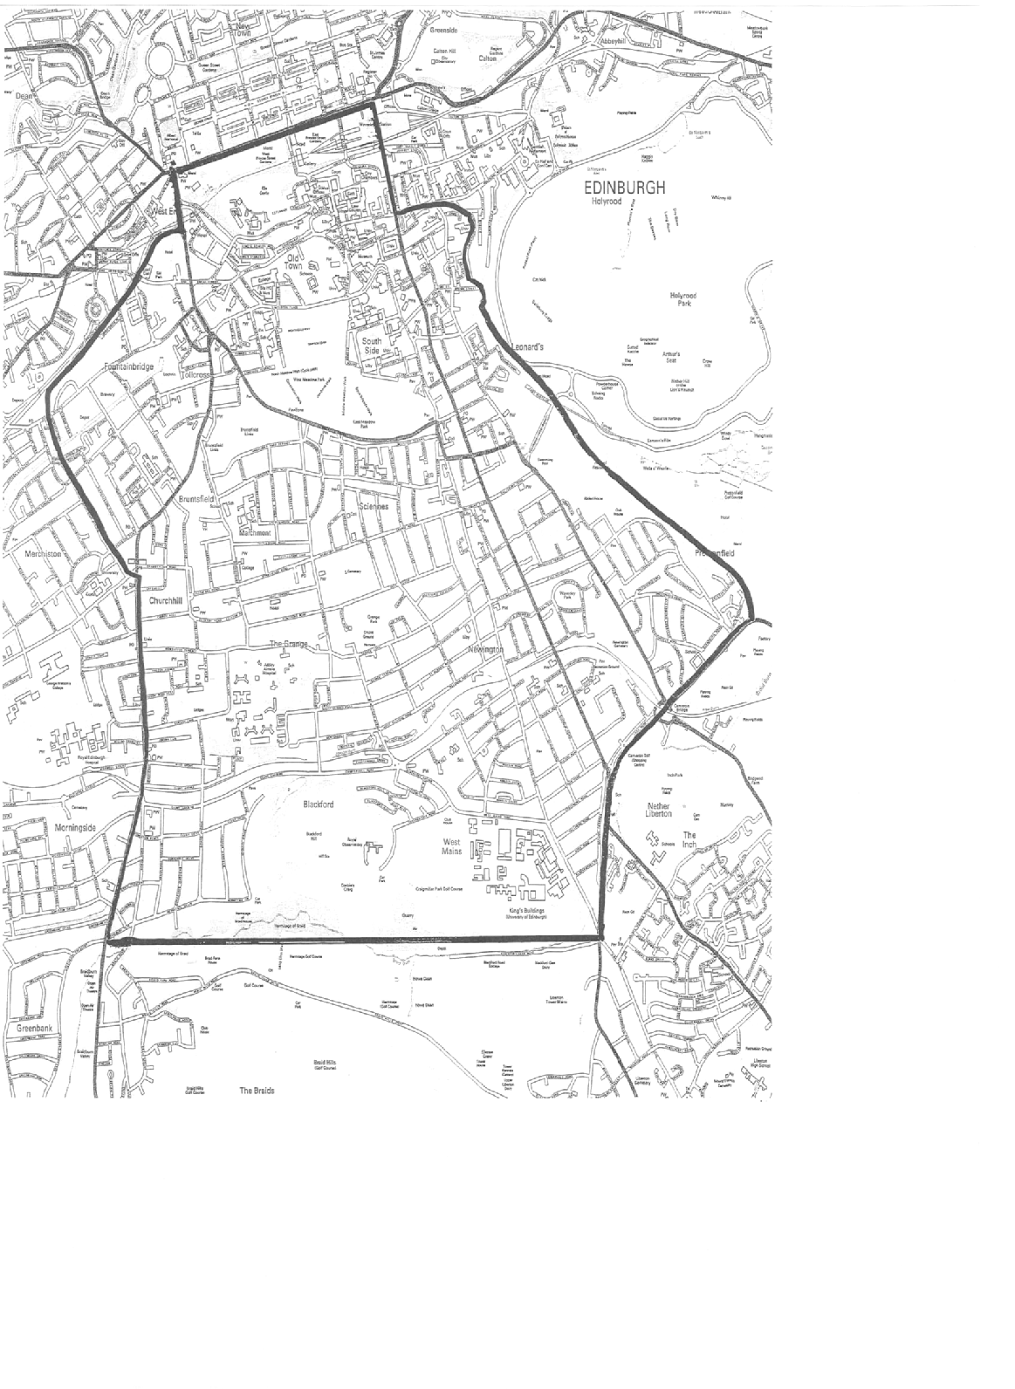.
The entrance to Richard Verney Health Centre is on the opposite side of
Bristo Square to the McEwan Hall – Our reception is on the 3rd floor.

ABOUT THE PRACTICE

The University Health Service is an independent National Health Service
partnership of general practitioners, who rent premises from the University, and
offer full GP services to patients who live within the practice area (see map page
4), and who choose to register with the practice.

TRAINING AND EDUCATION:
The practice has been recognised as the training practice for fully qualified doctors and medical students who have chosen general practice as their career. These doctors work with us and are available for consultation. Video equipment may occasionally be used with the patients consent and consultations with medical students will be checked by a fully qualified doctor as part of their training.

FACILITIES FOR THOSE WITH IMPAIRED MOBILITY/HEARING:
When the Health and Wellbeing Centre opens disabled access will be available via the main entrance there and up the ramp, through the automatic doors into the foyer at pharmacy with lift access through another automatic door to 3rd floor reception. Sign posting will be in situ.
A portable hearing loop system is kept at the 3rd Floor Reception Desk.

For now:
As the arrangements above are not yet operational please telephone 0131 650 2777 at least one day in advance of your appointment if you require escorted access into the building. This will be organised for you via this route until such time as the Wellbeing Centre fully opens.
.

HOW TO REGISTER WITH THE PRACTICE:
Please come in to the 3rd Floor Reception Desk. You will be asked to complete two
forms and may be seen by a nurse for a short medical assessment. These forms
can be downloaded from our website to allow you to complete them before coming
into the practice. Please bring with you two original forms of identification one of which must contain a photograph and the other proof of your address. We have to see paper copies of documents.

HOW TO SEE A DOCTOR:
For general medical consultations the surgery runs both an appointment system
and open access surgeries.

The consulting hours are listed on page 5 and a list of the times during which each
doctor is available is posted daily on the noticeboard at the entrance to the 3rd floor.

You can make an appointment with a doctor by telephoning 0131-650-2777 during opening hours. You may consult any of the doctors, however, if you have a continuing problem, it is better to see the same doctor for the duration of this. Routine appointments are usually 10 mins.
Please note that all calls are triaged by our receptionists to ensure that we signpost you to the correct health professional to deal with your concern.

We now offer our patients the facility to book & cancel routine GP appointments
online. If this is something that you are interested in then come in and speak to a
receptionist at the Health Centre and you will be provided with details of how to log
on to the appointments system.

OPEN ACCESS SURGERY:
If you are a registered patient and if you prefer, you can attend one of the Open Access surgeries without an appointment. These are popular surgeries allowing access to a doctor of your choice on that day from those consulting. Not all doctors are on open access each day and even your first choice doctor may be unable to see you subject to demand. Due to the popularity of this method of consultation, these surgeries can be very busy at times. We would like to suggest to you that for routine matters particularly if you wish to discuss more than one problem

5

it is better to plan ahead, organise an appointment and discuss your problem in a more relaxed manner with the doctor of your choice. If during your consultation
the doctor suggests that one or more of your problems would be best dealt with
by appointment please do not be offended as generally it will be in your best
interest.

EMAIL CONTACT
For confidentiality reasons please note that NO medical correspondence or requests for appointments or prescriptions can be accepted through the Practice email address.

PRACTICE NURSES
To book an appointment with any of the nurses telephone 0131 650 2777.

Our Clinical Support Worker provides a phlebotomy service (takes bloods), BP
checks, urine checks and flu vaccinations for over 65’s.

Our nurses provide a comprehensive travel clinic, a wart clinic, asthma
clinic, contraceptive advice and can issue some repeat contraceptive pills,
contraceptive injections and emergency contraception, cervical smears,
chlamydia testing, dressings, removal of clips and sutures, ear irrigation, blood
and urine tests, therapeutic injections, and offer general health advice. Annual reviews for long term conditions are also provided.

INTERPRETERS
If you feel that you will require a foreign language or sign language interpreter
to allow you to understand your consultation then please telephone reception a
few days in advance of your appointment to discuss this.

SURGERY OPENING TIMES: 8.00 am – 6.00 pm, Monday to Friday

APPOINTMENTS TERM TIME and VACATION

Monday - Friday 09.00 –10.00 Open Access Surgery
and Routine consultations by appointment throughout the day.
Routine appointments are usually 10mins.

PUBLIC HOLIDAYS: Closed (Dates for these are posted on our website)

HOME VISITS:
If at all possible we prefer to see patients at the surgery where full investigative
and treatment facilities are available, rather than at home. Should a home visit
be necessary we will be pleased to do this.

It is very helpful to us if requests for such visits can be phoned in before 10 a.m.
(tel: 0131-650-2777).

Please do not feel offended if the receptionists ask for some simple details
of your illness - it does help the doctor to arrange to see you rapidly if your
symptoms sound serious. The Duty Doctor may also telephone and speak to you.

EMERGENCY CALLS:
Between 08.00 and 18.00 hours, the Practice Duty Doctor can always be
contacted by telephoning: 0131-650-2777

Out of hours, (that is between 18.00 and 08.00 hrs, Monday – Friday, at weekends, and on public holidays) NHS Lothian is responsible for medical care.

To contact this service, please phone: NHS 24 on tel. No 111

NHS24 is also available for advice 24 hours a day, 7 days a week.
Tel. No. 111 website: www.nhs24.com

REPEAT PRESCRIPTIONS:
If your University Health Service doctor authorises repeat prescriptions for
you, you will be given a ‘Repeat Prescription Ordering Form’, detailing your
medicines and the number of occasions these may be re-prescribed before you
have to see the doctor to review your medication.

When you require ‘repeats’, please present the form at Reception (or send it in
with a stamped addressed envelope) and the prescription will be available for
collection by the end of the next working day. If you are registered for on line
booking you can request “repeats” on line.

Please note that you have to consult a doctor at the University Health Service
before you can use the repeat prescription facility.

TEST RESULTS:
Please telephone for test results after 11am, Monday to Friday

CHANGE OF ADDRESS:
It is essential that any change of address be notified to the practice as
soon as possible. Failure to do so may result in NHS Lothian withdrawing
your registration.

Please let us know your email address & mobile telephone number and
remember to tell us if you change these.

If you move outwith our practice area, you should register with a local general
practitioner. When in doubt about your address, please ask at reception.

Please email us on Univhealthserv@nhslothian.scot.nhs.uk (link via our website), phone us or call into the practice. Please state name, date of birth, old and new address details.

NON-NHS WORK:
Requests for completion of medical forms (e.g. Camp America), full medical
examinations (e.g. pre-employment, insurance) or shorter medicals should
be discussed with the 3rd floor receptionist in the first instance and not taken
directly into a GP appointment. This will be assessed on whether or not an
appointment is necessary and as this work is not covered by the National
Health Service general medical services, a fee will normally be charged. You
should then phone the surgery 24 hours after handing in your request for this
information. A charge will be made for private prescriptions issued by the
Doctors for travel.

7

SERVICES PROVIDED BY THE UNIVERSITY HEALTH SERVICE

CONTRACEPTION:
Contraceptive advice is always available from the doctors and nurses. We
are committed to providing a confidential and easily accessible contraceptive
service for our patients.

Contraceptive implants and intrauterine devices (IUD’s, IUS) are fitted and
removed by doctors at the practice in a dedicated, long acting and reversible
contraceptive (LARC) clinic. You will need to make an appointment at the clinic
or with any doctor/nurse for an initial discussion prior to insertion.

For routine, or emergency contraception, please see a doctor during
appointment or open access surgeries.

The nursing team can see patients for repeat contraceptive pill supplies of
certain brands, also for emergency contraception. A list of those included is
available at reception or on our website.

CERVICAL SMEAR TESTS:

A Scotland wide recall system is in place for women aged 25-65 years to allow them to have a routine smear and up to 70 for non routine patients. If you receive a letter offering you a smear then please call the practice to make an appointment with a nurse on 0131 650 2777.

Women up to age 50 will be screened every 3 years and 50-65 every 5 years.

CHILD HEALTH SURVEILLANCE CLINICS:
This clinic is run by a Health Visitor and a doctor on Wednesday mornings for
well baby checks and baby/childhood immunisations by appointment.

If you have a child under 5 years of age, please speak to the Health Visitor as
soon as your family register with us so that an immunisation schedule can be
worked out.

ASTHMA:
Appointments are available with our nurses to help those with a diagnosis
of asthma achieve a better understanding of the condition and gain optimal
control of it and for regular annual reviews. Please ask at reception or phone
0131-650-2777 to make an appointment.

TRAVEL CLINIC:
The Nursing Team run a Travel Clinic by appointment Monday-Friday. As these
are 30 minute appointments then please let us know in advance if you are
unable to attend the allocated appointment time. Please make an appointment
at least 6 weeks before you travel in order to allow time for any necessary
courses of injections. (tel: 0131-650-2777) There is a charge made for non -
NHS vaccines given.

PREGNANCY CARE:
The Doctors in conjunction with our Community Midwives are pleased to
undertake antenatal and postnatal care. Please speak to your doctor who will
make the necessary arrangements.

LONG TERM CONDITIONS:
Patients diagnosed with long term conditions such as heart disease will be
assessed regularly by nursing staff in conjunction with GP care.

DIABETES:
Diabetic patients need regular checks & review. Dr M Diamond oversees the care
of patients with diabetes who are registered at the practice in conjunction with
the hospital diabetic clinic where appropriate. Practice Nurses carry out regular diabetic checks as necessary & assist Dr M Diamond in this care.

PHYSIOTHERAPY:
Patients can look at www.nhsinform.co.uk/msk or call 0845 604 0001. This service is not provided by the practice but by NHS Lothian

CHAPERONES:
A doctor may ask one of the nurses to be present when undertaking an intimate
examination.

RIGHTS AND RESPONSIBILITIES

The University Health Service strives to provide first-class, confidential
healthcare, based on clinical need, to all patients, at all times without reservation.

To help us realise this objective we ask you to use the service responsibly –

• Be punctual and let us know if you cannot attend or no longer require an
appointment.

• Be polite and considerate to other patients, practice staff and doctors.

• Tell your GP and any hospital you are attending, if you change address or
telephone number

• Please make a separate appointment for each member of the family who
need to be seen

We aim to inform patients fully about any treatment or services offered.

Abusive, threatening or violent behaviour will not be tolerated under any
circumstances and the police will be called and you may be removed from our
list.

10

Fair Processing Notice

University Health Service keep records about your health and the care you receive. The records may include:
- Basic details about you, such as address and next of kin
- Contacts we have had with you, such as your appointments and clinic visits
- Reports about your health and any treatment/care you need
- Details and records about the treatment and care you receive
- Results of investigations, such as X-rays and laboratory tests
- Relevant information from other health professionals, relatives and carers

Information Sharing

The Practice complies with Data Protection and Access to Health Records
legislation. Identifiable information about you will be shared with others in the
following circumstances:

• To provide further medical treatment for you e.g. from the health visitors and
hospital services

• To help you to get other services e.g. from the social work department. This
requires your consent

• When we have a duty to others e.g. in child protection case

• Emergency care summary (basic health information is shared with out of
hours services to assist treating you when the surgery is closed)

• Some of your information may be used for clinical audit whereby a group of cases similar to your own is checked against agreed standards to identify where improvements can be made. Some of these audits are done over Lothian/Scotland or UK wide.

Anonymised patient information will also be used at local and national level
to help the Health Board and Government plan Services. If you do not wish
anonymous information about you to be used in such a way, please let us know.

Confidentiality

We maintain our legal duty of confidentiality to you at all times. We keep this information in a secure, confidential manner. All staff working within the Practice are bound by the same high standards of confidentiality. We will only ever use or pass on information about you if others involved in your care have a genuine need for it. We will not disclose your information to third parties without your permission unless there are exceptional circumstances, such as where health and safety of others is at risk or where the law requires information to be passed on.

We will not disclose any of your information to a family member without your consent If you do not want any of your information shared with a specific health professional then you must inform us of this in writing.

ACCESS TO HEALTH RECORDS

Patients have the right to access their health records from both paper and
computer sources. All such access applications must be in writing and addressed
to the Practice Manager in the first instance. Specific details must be given as
to the extent of access required identifying dates of entries within the record.

Any confidential reference in the records to third parties will be deleted. In
the extremely rare occasion of a record containing information harmful to the
patient this will be deleted.

PUBLICATION SCHEME

The Practice operates a publication scheme in compliance with the Freedom of
Information (Scotland) Act 2002. We use the BMA Scotland format. Details of the scheme or a request for access should be made to the Practice Manager.

SUGGESTIONS:

If you have any suggestions whereby we might improve the service to you as a
patient, please let us know.

A suggestion box is available on the shelf at the entrance to the 3rd Floor.

COMPLAINTS:

This practice makes every effort to provide a good service but if you have any
comments, compliments or complaints, please ask the receptionist for our
leaflet giving details of the practice complaints system and how to proceed.

LOCAL HEALTH BOARD:

Details of primary medical services in the Lothian area may be obtained from

NHS Lothian
2ND Floor
Waverley Gate
2 -4 Waterloo Place
Edinburgh EH1 3EG

Tel: 0131 537 8423

