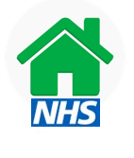

Post Coronavirus Rehab Advice Line
09:00 – 12:00 - 07969334704

For patients who have concerns about their recovery from Coronavirus

